REVISI ABSENSI OKK RK 385

# 17-09-21

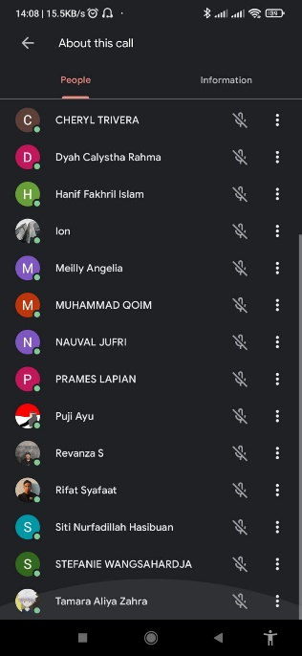

# 24-09-21



# 01-10-21

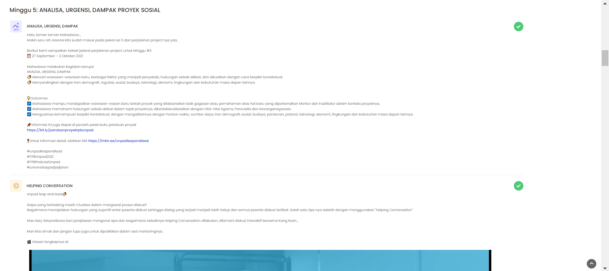

# 08-10-21

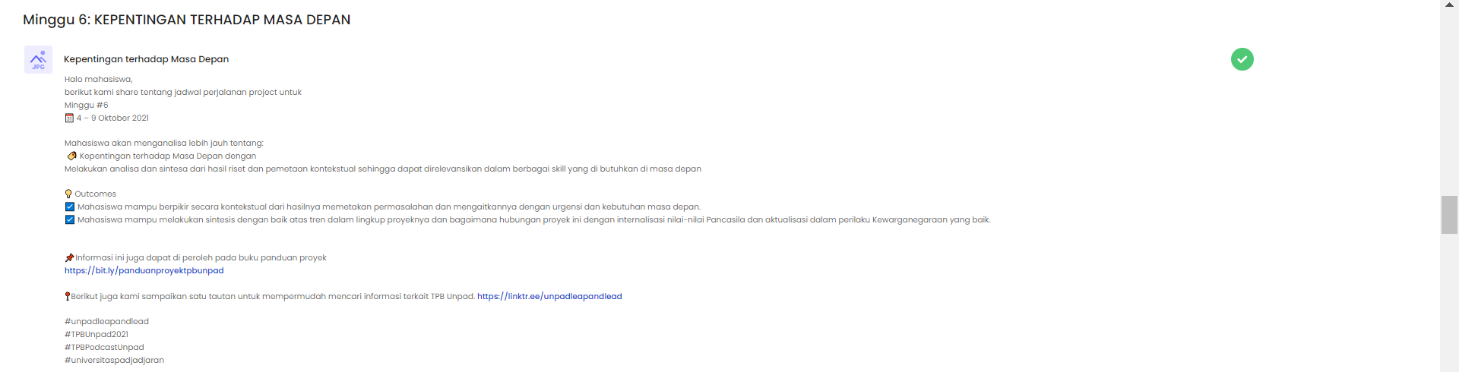

# 15-10-21

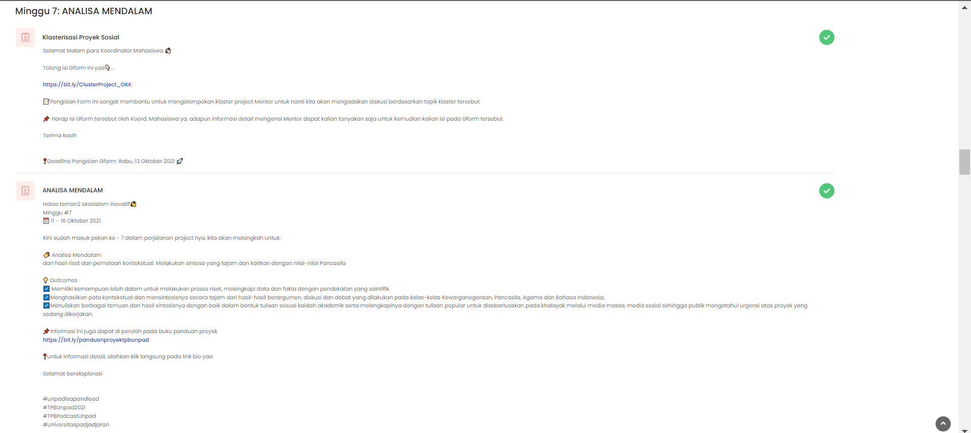

# 22-10-21



# 29-10-21

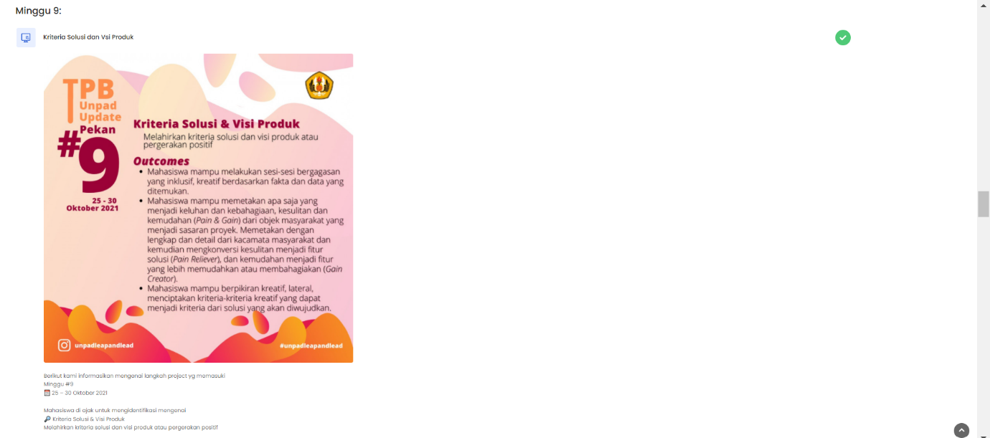

# 05-11-21

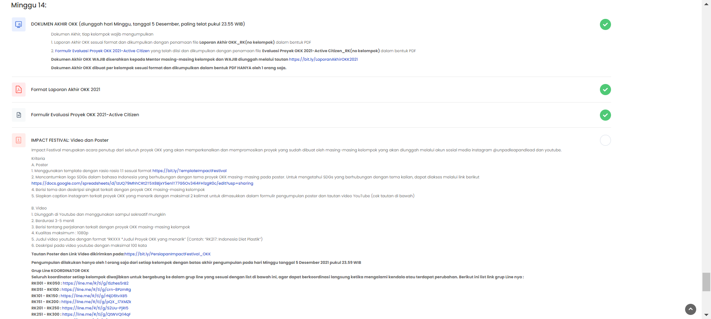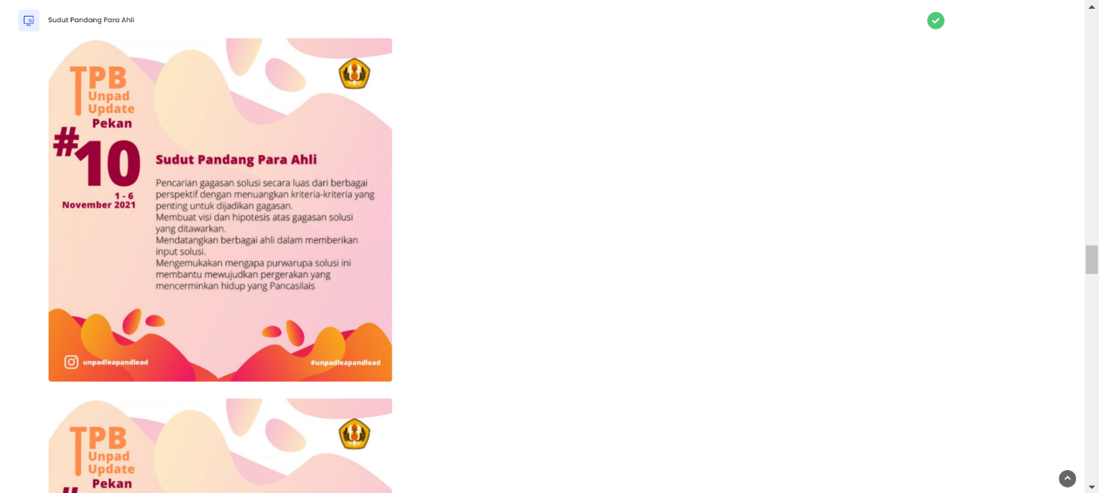

# 03-12-21

